**Website Needs and Assessment**

# Company Information

What does your company do?

Clark Communities Bicycle and Pedestrian Advisory Committee

* Implementing the vision of the Clark County Bicycle and Pedestrian Plan
* Commenting on plans and proposals for road and other transportation projects impacting bicycle and pedestrian usage.
* Assisting county, city, and state governments in the design and implementation of a comprehensive pedestrian and bicycle plan for Clark County.
* Advising on the implementation of the county’s recently adopted Bicycle and Pedestrian Plan.
* Evaluating and making recommendations to staff regarding design standards for all types of pedestrian and bicycle facilities.
* Making recommendations to staff regarding prioritization and improvement of pedestrian and bicycle facilities.
* Advising agencies on ways to improve bicycle and pedestrian safety.
* Encouraging walking and cycling as forms of transportation.
* Focus on top recommended programs from the Clark County Bicycle and Pedestrian Master Plan

What is your role in the company?

The role of the CCBPAC is to advise the county and participating city and state government staff on matters involving bicycle and pedestrian transportation.

Does the company have an existing logo, brand, or identity guidelines?

Yes, created by a Clark College Graphic Design student, Jordan Heup-Vidinha, 2015

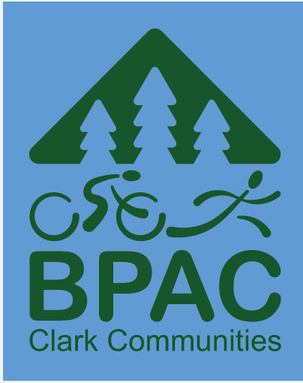

What is your current web address?

[www.clark.wa.gov/bpac](http://www.clark.wa.gov/bpac)

# Goals, Objectives, and Target Audience

What is the main message you wish to convey to your audience?

An easy-to-use learning resource meant to help fill and educational gap for both bicyclists and motorists.

What are the secondary objectives you hope to achieve?

Increase knowledge, improve safety and compliance with the law, and lessen conflicts and tension between bicyclists and motorists on our roadways.

What are the goals you wish to reach with this website?

Learning how bicyclists and motorists can share the road. Reduce injuries and deaths, too many people afraid to bike, and anger and resentment on both sides.

Who is your target audience? Are there any common demographics, such as age, sex, or physical location?

Child bicyclist, adult bicyclist, motorist, driver’s education.

# Perception

Use three adjectives to describe how the website should be perceived. (Examples: conservative, flashy, progressive, friendly, serious, professional)

Conservative, friendly and professional.

Is this different from your current image?

No.

What do you feel is the biggest challenge in getting this image across to your audience?

The biggest challenged is to earn the willingness for bicycle riders to apply the law and motorists taking the time to look for bicyclists.

How are you currently perceived?

Bicycle riders do not follow the law. Motorists do not look for bicycle riders.

# Competition

List sites of competitors site and briefly state what you like and dislike about their overall site.

None known.

How do you differentiate yourself from competitors?

This is a government agency that is not for profit.

What are the key reasons customers choose your company?

Key reasons include serving as an official body of law that knows the law.

# Action

What is the primary action you wish your audience to take from the main page of your site? (examples: download, browse, move along a specific path, email, order, explore, click button, call via phone, etc.)

Explore the webpage.

What is the primary action you wish your audience to take before leaving you site? Is it the same action as #1? If not, please describe.

What elements are key items you wish to be available on every page?

Questions and answers, and when needed pictures.

# Content

What information do you wish to provide online?

Content similar to link below.

<http://www.bikesafetyquiz.com/>

Will this website use existing content? If so, what is the source and who is responsible for approval? If not, who will be producing the content?

Gary Albrecht will provide the questions and answers.

What content needs to be written or produced?

All questions and answers.

What is the basic structure of the content and how is it organized?

Question and answer.

What elements should appear on every page?

Questions and answers.

# Design

## Colors

What colors do you want to use for your website?

Something that blends with existing web page.

[www.clark.wa.gov/bpac](http://www.clark.wa.gov/bpac)

What colors do you not want to use for your website?

Something that blends with existing web page.

[www.clark.wa.gov/bpac](http://www.clark.wa.gov/bpac)

## Typography

What fonts do you want to use for your website?

Something that blends with existing web page.

[www.clark.wa.gov/bpac](http://www.clark.wa.gov/bpac)

What fonts do you not want to use for your website?

Something that blends with existing web page.

[www.clark.wa.gov/bpac](http://www.clark.wa.gov/bpac)

## Imagery

What imagery do you want to use on your website?

Non-copy right images.

How will you purchase/license the imagery?

No plans to purchase imagery.

## Multimedia

How will you use video or animation content on your website?

The bike safety quiz will be listed below Related Information below.

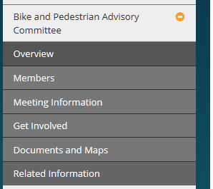

[www.clark.wa.gov/bpac](http://www.clark.wa.gov/bpac)

# Development

## Technology

What is your server configuration? Can you run PHP? If so which version?

Are there specific technologies you would like to use?

Will you need database functionality?

## Administration

Do you want to be able to administer your website?

Yes.

## Website Hosting and Domain Ownership

**Yes, I have permission to upload and manage this webpage.**

[**www.clark.wa.gov/bpac**](http://www.clark.wa.gov/bpac)

Do you currently have website hosting services? If so, who do you host with?

Do you own your domain name? If so, which company holds your domain?

Yes.

## E-Commerce

Will you be accepting payments through your website?

No.

Will you be using a 3rd party payment processing company? If so, which company?

No.

# Social Media

What social media networks do you currently use?

None.

How do you want your website interact with those social media networks?

If any social media, it would go through [www.clark.wa.gov/bpac](http://www.clark.wa.gov/bpac)

# Marketing

What are your short-term marketing goals?

Clark County Press Release, share with neighborhood associations, and public officials.

How will this website help to reach those goals?

It will provide bike safety to share with the County.

How will you promote this website?

Clark Communities Bicycle and Pedestrian Advisory Committee

What do you feel is your number one business problem?

Not sure.

# Timeline and Budget

What is your project timeline and budget?

No specific timeline and no budget outside of my staff time.